

ST3189-02 Machine Learning Coursework

Mario Javier Rodriguez Ureta
PgD in Data Science – April 2021
Contents
Unsupervised Learning Techniques 3
Description of the European Working Conditions Survey 2016 3
Data 3
Processing the Data 3
Clustering our data 4
Conclusions 4
Regression Models 5
Description of the database 5
Processing the data 5
Boosted trees 6
Lasso regression and onterpretation of the Lasso coefficients 6
Classification Problems 7
Description of the database and LDA 7
Binary Logistic Regression 8
Table 1: PCA Rotation Matrix 10
Figure 1: Biplot PC1 and PC2 10
Figure 4: Ridge Regression (no variables selection) 11
Figure 5: Boosted Trees for Part II 11

Unsupervised Learning Techniques

Description of the European Working Conditions Survey 2016
Since its introduction in 1991, the survey aims to monitor working conditions across the EU, analyze the differences between the different variables in the survey, identify issues of concern, and contribute to developing EU labour policies (Eurofund , 2017 Update ). The survey includes workers from all 28 countries with the addition of the EFTA members and candidate countries.

Data
Our data consists of lifestyle questions and feelings (relaxed, calmed, cheerful, etc.) at work and on a personal level. Participants were coded by age and gender. The level of agreement (i.e.: ‘most of the time’, ‘all of the time’, etc.) was recorded as a numeric value from 1 to 6.
To make sense of this data, we start applying a technique called Principal Component Analysis (PCA) to our raw data. This technique allows us to reduce the size of our data, making interpretation easier with minimal loss of information. Depending on our findings we may move onto cluster analysis, another statistical technique that allows researchers to group participants that share common traits. In the end, we hope to find relations or traits that help to understand our data.

Processing the Data
We start preparing the data and, after a quick examination, we remove the null observations and decide, initially, to scale the data. We run both a rotation matrix and a summary on R (see Table 1: Rotation Matrix) and we can, at first glance, have a good idea of what is going on.
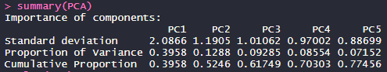
The above table shows us the first five principal components. The first component (PC1) explains 39.6% of the variance, the second explains 13% of the variance, and so on.
From the fourth principal component onwards, the additional explained variation is marginal: less than 10% on each component.
Table 1: Rotation Matrix, contributes with more information: the most important factors (values close to 1) on PC1 seem to be cheerful, relaxed, active, rested, and interesting. On PC2 instead, are all the positive variables that are work-related.
The Biplot (see Figure 1) gives us a graphical representation of both the direction and magnitude of the two main components (PC1 and PC2), as well as the sign of the direction (positive or negative influence). PC1 is mainly affected by home-related factors such as interesting, rested, active, relaxed, etc. (what we could call personal circumstances) while PC2 is formed by work-related factors (enthusiastic at work, time flies at work, I am good at what I do, etc.). Most of the variables loading form a small angle between each other, meaning that are closely positively related (i.e., rested and relaxed). Being separated by 90 degrees angles means the opposite: related and I am good at my work form are not correlated at all.
Having now a good idea of the principal components in our survey, we will move to the next step: clustering.

Clustering our data
Our previous step gave us a good idea of, potentially, how many clusters we need: the first four principal components explain a 70% of the total variance in our data. Before running our K- mean clustering analysis using k=4, we will choose k employing an elbow plot (see Figure 2). Having chosen our k using cross-validation and PCA, we can now run our k-means clustering analysis. Our analysis in R, confirms what we have already discovered using PCA with the addition of cluster means for each cluster.
Our four clusters have sizes 2361, 1259, 2187, and 2006.
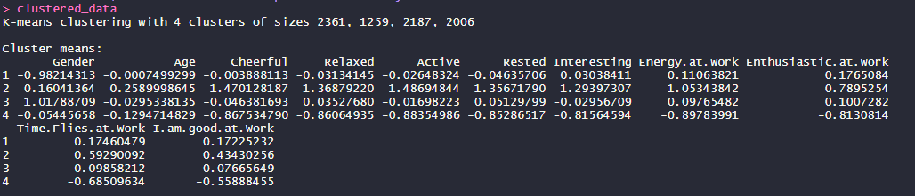
The cluster means’ table provides us with further information. In cluster number one, gender has the largest mean, followed by I am good at work, Time flies at work, and Enthusiastic at work. Note here how closely correlated are here also in value: 0.176, 0.174, and 0.172; this confirms our findings from the Biplot. In cluster number two, cheerful, relaxed, active, and rested are the variables with the largest means.
Before completing our unsupervised analysis, we tried performing hierarchical clustering to plot a dendrogram plot. Sadly, our dendrogram is clear enough to allow us to read out which participants belong to which cluster.

Conclusions
The data in this part of the assignment presents fits under the category of exploratory analysis, and while it does not seem particularly adaptable for forecasting or regression, it can provide very useful information. Its main advantage consists in making no assumptions at all about the shape or size of the data, allowing us to find impartial relationships. Personal circumstances have a much larger weight in performance than once could have guessed (PC1 explains 40% of the variation). Surprisingly, work-related factors account for just 12% of the variation, suggesting that regardless of age and profession (age was not particularly significant in our clustering model) the impact of free time and balanced personal life has a larger impact on productivity than originally thought. Still, because productivity levels were not included in our data, these findings should be followed by further research between productivity levels and leisure time.

Regression Models

Description of the database
The database consists of social and demographics characteristics of students of mathematics and Portuguese language. Questions range from personal circumstances, such as romantic relations, support at home to family characteristics (type of job of mum and dad, income, choice of school, etc).
The aim here is to predict final grade levels based on these variables while understanding which one explains more of the variation in the final grades.

Processing the data
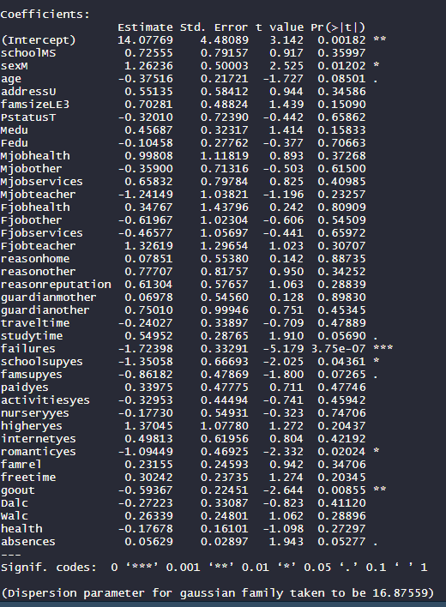
We start cleaning our data and removing G2 and G3 from our database. Despite having different features in our data (age and 1 to 5 numeric values) we do not need to normalize : this is because linear regression looks at the proportion between independent variables and normalizing will just scale our coefficients. After running a linear regression of the data, including all coefficients, we found that, for the math students, just a few variables are of statistical interest: sexM, failures, school support, romantic (yes), go out, and absences. Assuming that this linear relationship exists, we may initially say that,
- Male students tend to perform better than their female counterparts.
- Previous failures have a strong weight on final results: one unit increase of failure reduces final grades by 1.723 units.
- Similarly, romantic life (yes), reduces school performance by 1.094, while going out (the time spent on social outside school activities) by 0.59.
- Strangely, the level of absence seems to have little weight on the final grade.
We now validate our findings on our test data and check for divergences. On the validation set, our model RSD is 4.086 (residual standard deviation) and 2.66 for students of the Portuguese language. Bearing in mind that our dependent variable is the final grade and that the final grade is scaled between 0 and 20, 4 standard deviations (on average) does not seem too bad. Still, the assumption of linearity seems too rigid in this case.
Consequently, we run our data under a boosted tree model because we, precisely, want to relax the idea of linearity implicit on simple regression and investigate if we can find a model with a lower test RSD and, hopefully, finding more significant variables.

Boosted trees
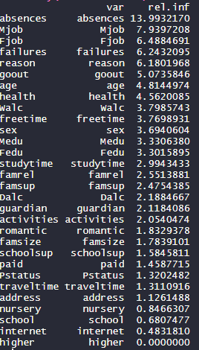
Here, we find similar findings as above, but with the addition of father and mother job as a factor with higher relative influence. Absences have now a much higher coefficient (14), followed by mother and father job (parents’ expectations?), failure on previous exams, and the reason that the school was chosen in the first place. These findings start to make a lot more sense now, but they do not allow us to make and predictions because boosted trees do not provide us with coefficients (in this case).

Lasso regression and interpretation of the Lasso coefficients
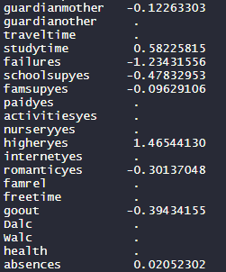
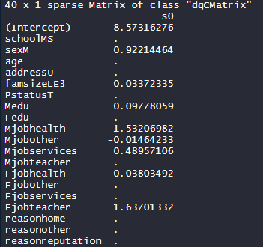
Finally, we run both a Ridge and a Lasso Regression to not just being able to perform regression, but also to reduce the number of variables (through the Lasso Regression). Figure 4 shows the plot for the Ridge Regression and while we cannot start eliminating here variables still we can read out the coefficients in order of importance and allow us to compare it with the variables of interest in our boosted tree model: ‘Go_out’, ‘free time’, ‘health’, ‘Dalc’ and ‘Walc’, (work and weekend alcohol consumption) have negative coefficients: as one unit of these variables increases, final grades decreases by -0.13 units (not particularly high).

Finally, we run cross-validation on our lasso regression to determine the best value of lambda: 0.203589. Having the right lambda value allows us to run a Lasso regression and by forcing some coefficients to zero, we end up having a final set of variables (see below). We finally end up with a reduced model that allows us to make grade predictions based on a much shorter number of independent variables (both of qualitative and quantitative nature

Classification Problems

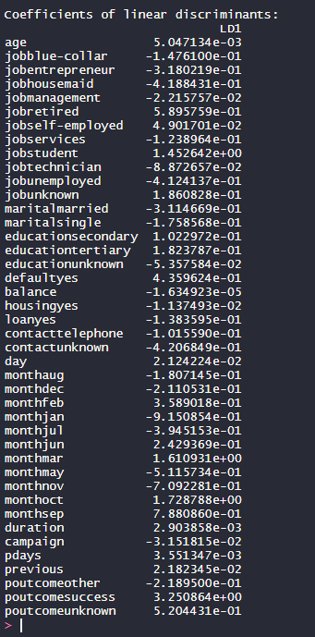
Description of the database and LDA
Client data from a Portuguese bank. The goal here is, based on these variables of interest, to construct a model able to predict client subscription to a term deposit and to evaluate the model's predictive capabilities. We already know, based on our data how many clients have subscribed (yes) to the term deposit, hence our techniques will be chosen based on their predictive performance: in other words, we will select the technique that correctly predicts most cases. We start with linear discriminant analysis (LDA): in the context of regression, LDA, assigns a possibility of observation to belong to a class by creating linear discriminant regression lines. In our analysis, it has created just one (LD1 on the figure to our left) and outputs the coefficients for each of the variables. Prior possibilities in our (training data) are 89% no’s and 11% yes. Interestingly, most of the coefficients are negative, indicating that these variables are averse to subscribe to the term deposit. Specifically, retired, and self-employed people seem to be prone to accept the proposition, while technicians and housemaids are much less likely to accept the deal. September seems to be the best month to make the phone calls, and the successful outcome of the previous campaign has a positive incidence too (this may indicate that the customer is more receptive and engaging/familiar with the bank). The level of education or marital status seems to have truly little incidence. After testing our model on our validation set and create a confusion matrix, our LDA model correctly predicted 63% of the yes cases and correctly predicted the no cases 94% of the time. Not bad, but not great, considering that a random model will correctly predict the yes cases 50% of the time. We will now try a logistic regression (another model) and we will check its efficiency.

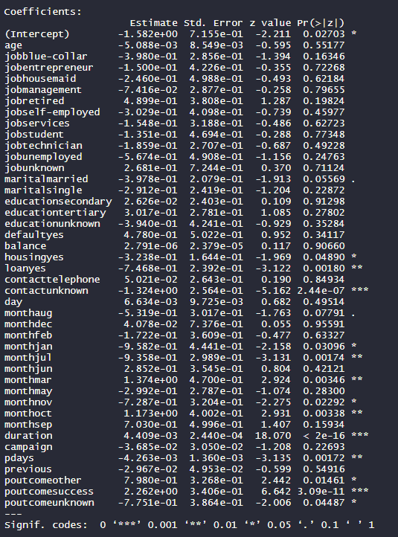
Binary Logistic Regression
Apart from calculating the coefficient of our variables, this model also estimates the p-value of each independent variable. Here the only statistically significant variables are, ‘housing_yes’, ‘loan_yes’, married, and success_previous_outcome. Duration is also significant, but it will not be considered due to being highly correlated with the outcome.

Interpretation of the variables
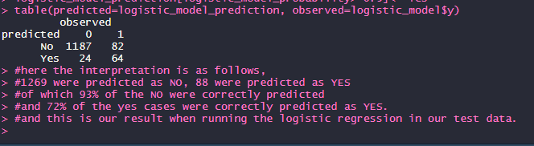
Accepting this predicted model will imply for managers that to increase their success rate they should aim to a demographic that possess a mortgage and/or loan (maybe low risk-averse?), is married in a stable relationship, and, ideally, has participated in previous campaigns. Our model correctly predicted the yes outcome 72% of the time when we run the regression in our validation set (see the confusion matrix), indicating an improvement in the model. Finally, we run a boosted tree analysis of the same database, but this time we have eliminated the duration variable due to be highly correlated.
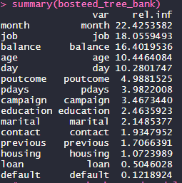
As expected, month has the largest relative influence, and this agrees with our previous findings: five out of twelve months were statistically significant. Balance and job were not statistically significant but still hold considerable weight. Previous outcome appears as influential here with a value of five, followed by marital status and previous contact (both significant in our previous analysis). Overall, our model seems to reasonably predict an outcome based on, arguably, varied variables (marital status, level of contact, previous bought product (mortgage and loan), amongst others.
Apart from the relatively good predictive capabilities of our final binary model, the interpretation of the variables has practical implications for bank manager, such as (but not exhaustive):
- Previous campaign is positively correlated. Make the (next) product familiar for new and existing customers by relating it with pre-existent and familiar products.
- Mortgage and loan owner statistically significant. We can conclude that this demographic is highly likely to consume this and, potentially, new bank products. Whether this is because they are familiar with the bank, have a stable job/income, or because they are risk-averse, should be further study.
- If the product is a more traditional one (savings account, loans, etc), it may be the case that it should be directed to a more traditional, risk-averse demographic. Products slightly more ‘controversial’ (financial tools) to a maybe younger and risk-lover sector?
- Re-evaluation of the phone-marketing strategy? The fact that none of the job categories (were large indeed) were not statistically significant may imply that either the product was not properly explained, or it took too long to be explained.
Finally, this predictive model can be used to predict the success of future campaigns, aiming at specific demographics to increase the number of sells, while also reaching the less likely to buy categories in a more refined and aimed strategy.

Tables and Graphs

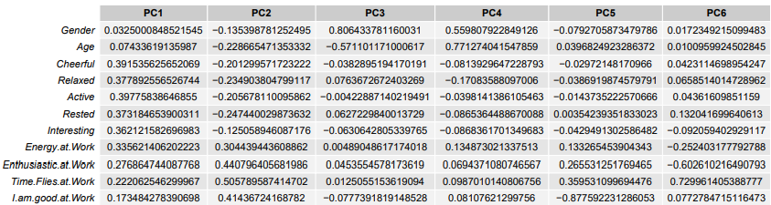
Table 1: PCA Rotation Matrix
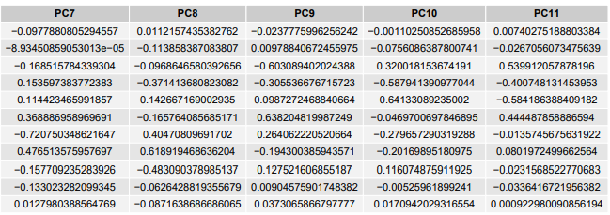
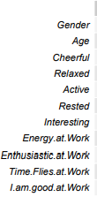

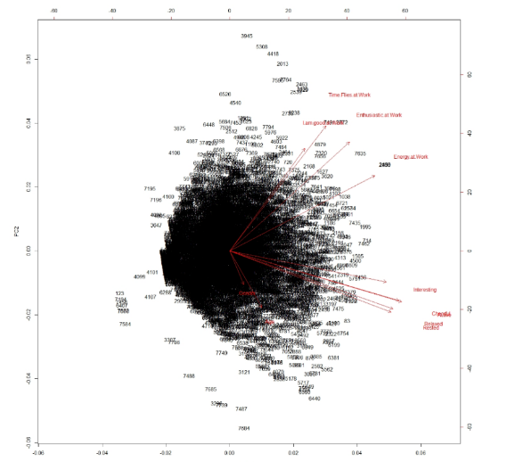
Figure 1: Biplot PC1 and PC2

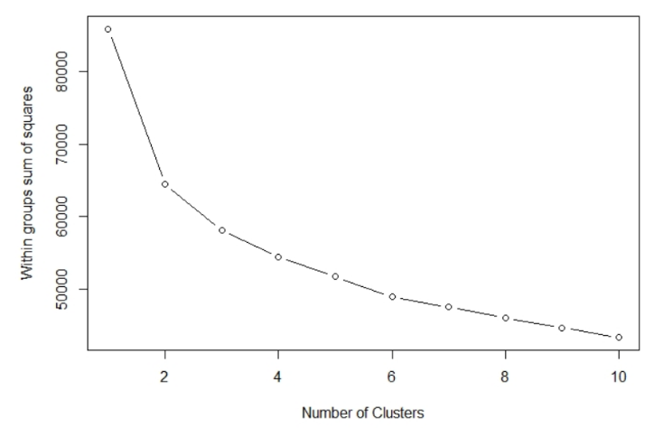
Figure 2: Elbow Plot

Figure 3: Dendrogram
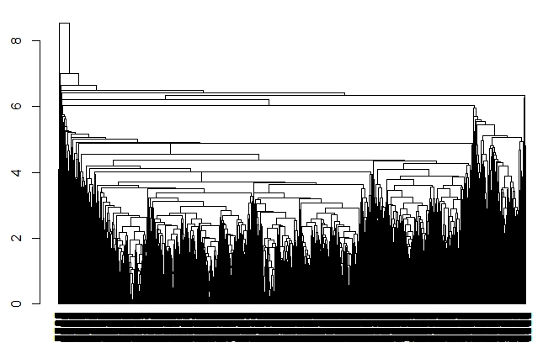

Figure 4: Ridge Regression (no variables selection)
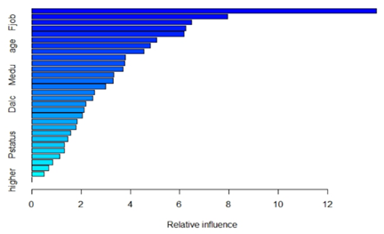
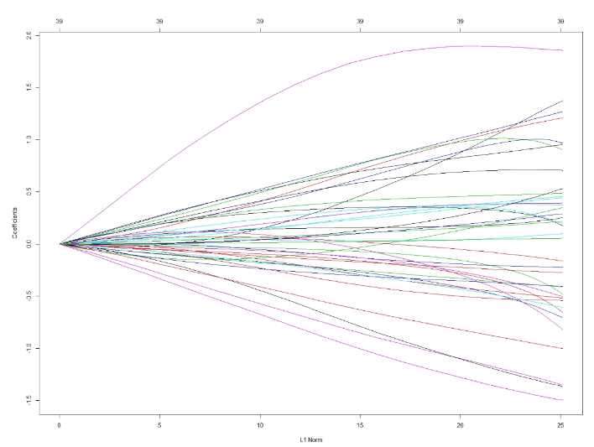

Figure 5: Boosted Trees for Part II

Norway and Switzerland
Albania, Montenegro, Turkey, and Macedonia.
Our output in R produced 11 PCA’s.
A plot of the within sum of squares vs the number of cluster. Where the plot shows an ‘elbow’ is where we choose the number of k clusters.
Note that the rotation matrix and the cluster means are not the same: the first one means the correlation within the variables while the second calculates the means of each variable per each cluster.
A dendrogram plot is a graphical representation of the clusters, shaped like an upside-down tree.
(x-min(x)/(max(x)-min(x)). For a single observation, it is the ratio of how far my observations is from the minimum value and the range.
Here one could argue that a higher level of absence is strongly related with other variables such as school support, romantic, activities, family support, health and free time. Maybe the reasoning here should be the education should be understood under a holistic approach rather than just a simple matter of curricular content or activities.
While alcohol consumption may seem irrelevant when analysed individually, it should be seen together with the other variables with negative coefficients: going out, romantic life, etc.
In fact, looking at our data we know hoy many subscripted (yes) and how many rejected it (no).
If the duration is zero (we could not contact the customer), of course the answer will be no.

